You are given the root of a binary tree where each node has a value 0 or 1.  Each root-to-leaf path represents a binary number starting with the most significant bit.  For example, if the path is 0 -> 1 -> 1 -> 0 -> 1, then this could represent 01101 in binary, which is 13.

For all leaves in the tree, consider the numbers represented by the path from the root to that leaf.

Return *the sum of these numbers*. The answer is **guaranteed** to fit in a **32-bits** integer.

**Example 1:**

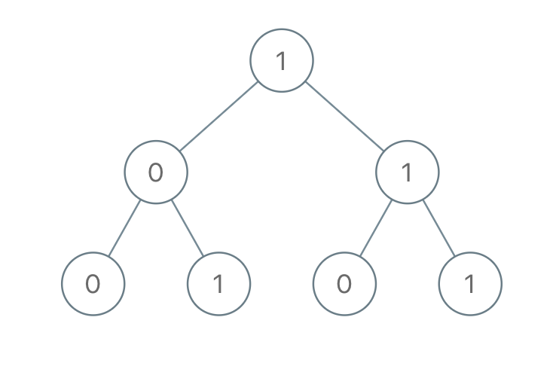

**Input:** root = [1,0,1,0,1,0,1]

**Output:** 22

**Explanation:** (100) + (101) + (110) + (111) = 4 + 5 + 6 + 7 = 22

**Example 2:**

**Input:** root = [0]

**Output:** 0

**Example 3:**

**Input:** root = [1]

**Output:** 1

**Example 4:**

**Input:** root = [1,1]

**Output:** 3

**Constraints:**

* The number of nodes in the tree is in the range [1, 1000].
* Node.val is 0 or 1.